## horizontal line

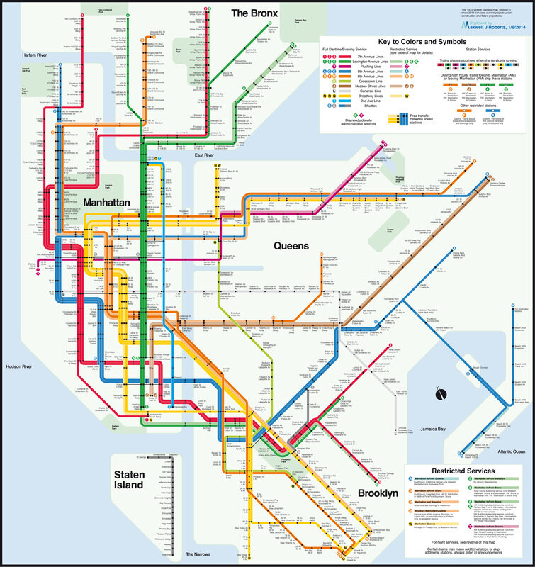

311 Calls in New York (2010 - Present)

Analyzed with Elasticsearch/Kibana/Logstash

01.19.2021

Filipe Soares

CSDA 1020

# Overview

Over the past 10 years, the city of New York has received about 25 million 311 service calls. Each day the number increases as the citizens request assistance with loud neighbours, maintenance issues in their apartments, illegally parked cars and many other issues. The city has requested data analysis on the daily calls which will help with understanding what kind of problems New Yorkers face regularly and where they should deploy their workers to provide quick and efficient solutions to these issues. The analysis was carried out with the use of Elasticsearch, Kibana and Logstash. Due to the large data set, there were difficulties loading the entire file into Kibana. However, over 5.4 million documents were loaded which is large enough to generate insight from the data. The logstash file and the geo-point template can be found in the appendix.

# Analytical Questions

The following requests were made for the report to identify any patterns with regards to the frequency of 311 calls and where they occur:

1. Create a table showing the top 10 cities with the highest calls alongside the count of top 10 complaint calls (by Descriptor) in each city
2. Create a pie chart showing the top 5 cities with the highest calls alongside the top five calls (Descriptor) in each city
3. Create a tag cloud representing the top 20 call descriptors
4. Create a coordinated map of all the major call descriptors in each city
5. Create a dashboard for all visualizations of 1to 4 above

Another visualization was created to highlight the top 5 agencies called and the top 5 cities they are called to. This information will be useful in determining what agencies may require the most funding as well as the locations in which they should be deployed.

# Results

Top 10 Cities and their Top 10 Descriptors (Data Tables)

Before creating a table containing the top 10 cities and their top 10 descriptors, another table with only the top 10 cities and the total count of complaint calls was made. The top 10 cities by complaint calls are Brooklyn, New York, Bronx, Staten Island, Jamaica, Flushing, Astoria, Ridgewood, Ozone Park and Fresh Meadows. Brooklyn has the highest total calls at roughly 1.73 million, almost 700,000 more than the next city of New York which had about 1.04 million. These results can be found in Figure 1.

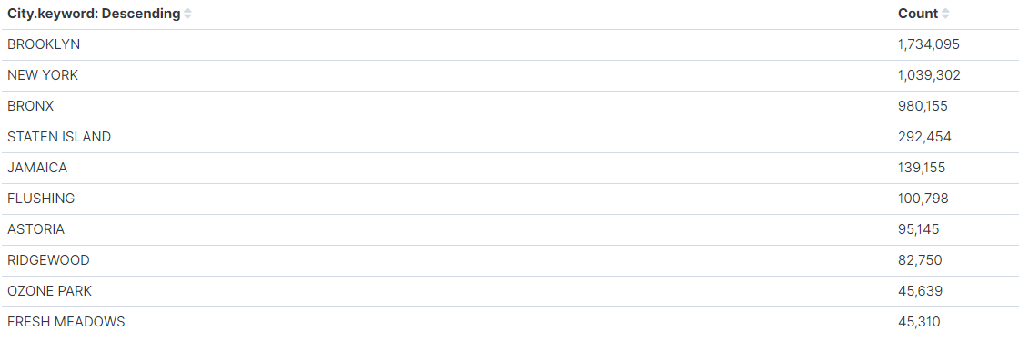

**Figure 1. Top 10 cities by complaint calls**

After identifying the top 10 cities, the table was modified to identify the top 10 call descriptors in each of those cities. The two descriptors that are most common in each list are for loud music/party and requests for large bulky item collection. These can be found in the top 3 of most cities, with loud music being the number one complaint descriptor in Brooklyn, New York, Bronx, Jamaica, and Astoria. Large bulky item collection requests the number one descriptor in Staten Island, Flushing, Ridgewood and Ozone Park. Figures 2.1 and 2.2 contain the top 10 cities and call descriptors.

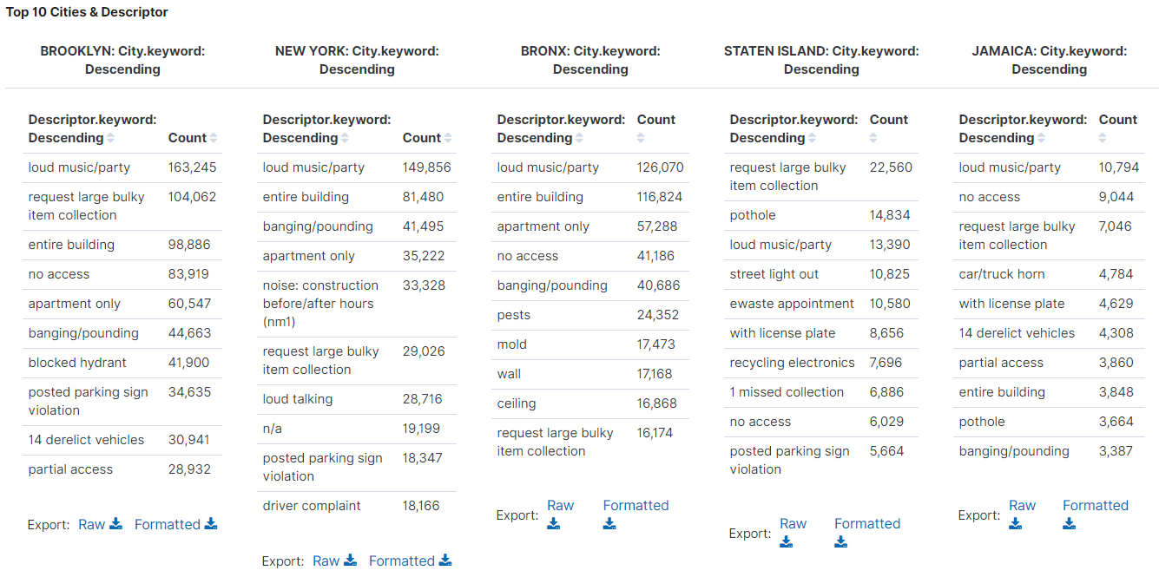

**Figure 2.1. Top 10 cities (1-5) and their top 10 descriptors**

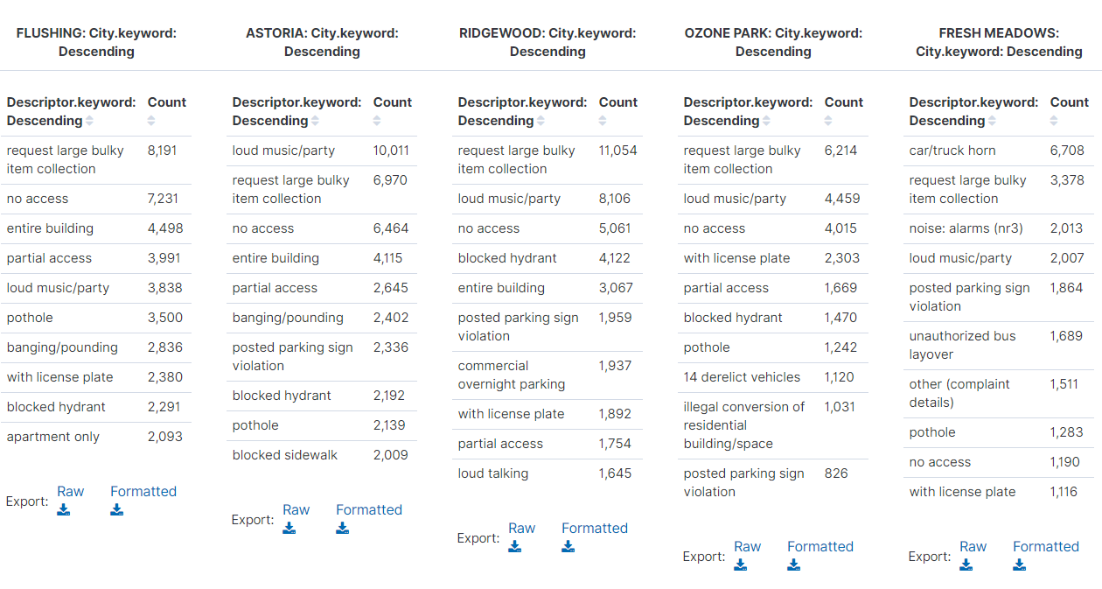

**Figure 2.2. Top 10 cities (6-10) and their top 10 descriptors**

Top 5 Cities and their Top 5 Descriptors (Pie Chart)

The next method of analysis performed was examining the top 5 cities by complaint and their top 5 descriptors. As discovered earlier, Brooklyn, New York, Bronx, Staten Island and Jamaica are the top 5 cities for complaint calls made. Brooklyn is by far the most common city to receive complaint calls as it makes up 41.4% of the total calls among the top 5 while Jamaica makes up just over 3%. The next step was to add the top 5 descriptors for each of the top 5 locations.

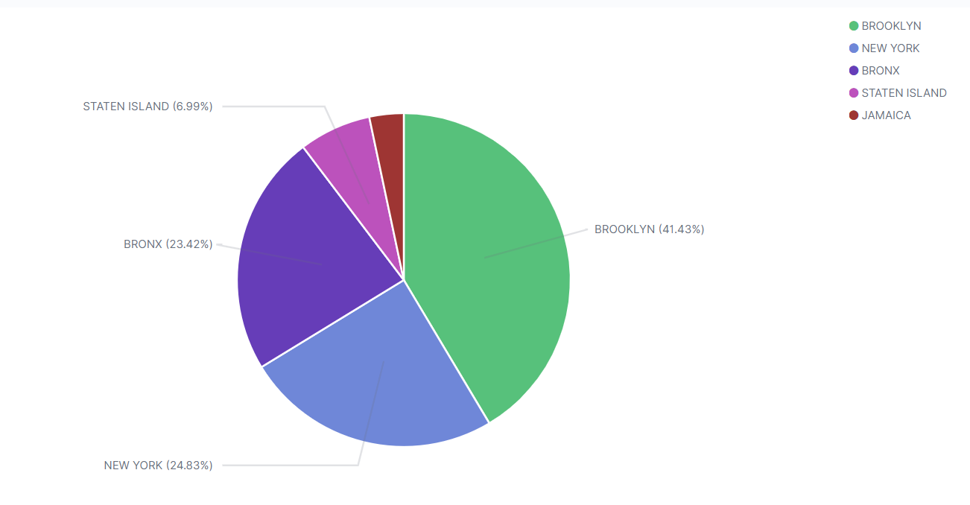

**Figure 3.1. Top 5 cities for complaint calls**

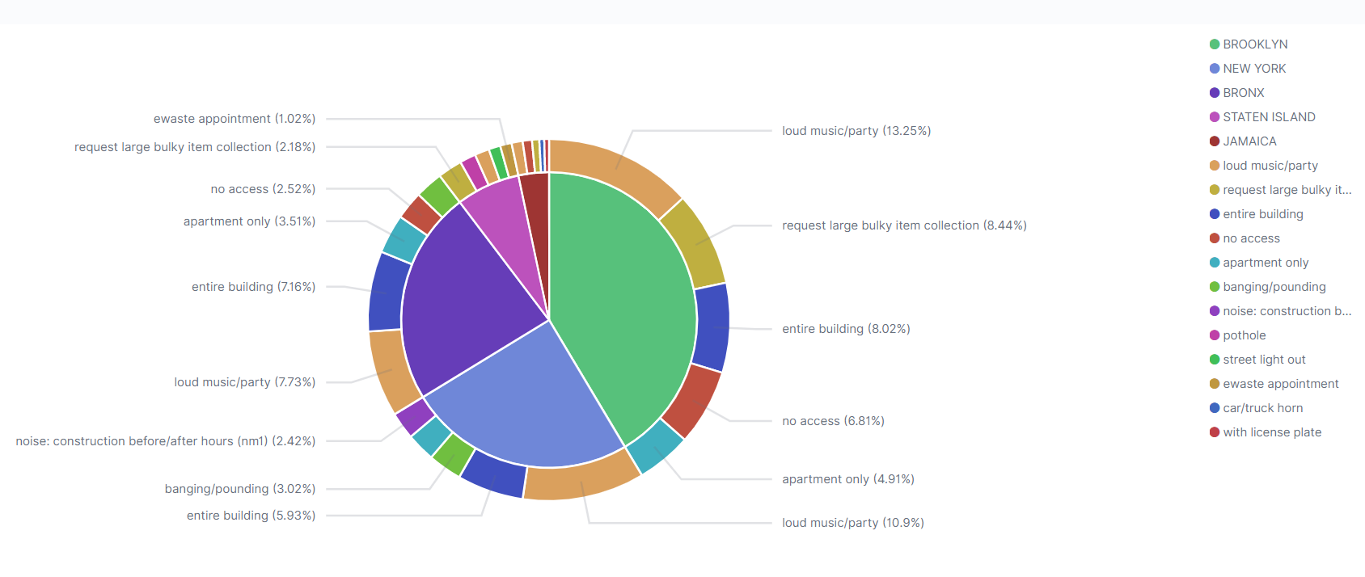

**Figure 3.2. Top 5 cities and top 5 descriptors in each city**

The most common complaint descriptor was “loud music/party” as can be seen with the light orange tiles. This appeared in each city and was the number one complaint in all locations except for Staten Island. The descriptor labelled “entire building” is the second most common among the top 5 cities and can be identified with the dark blue tiles.

Top 20 Complaint Calls and Descriptors (Tag Cloud)

The most common complaints and descriptors are perhaps best most easily understood in a tag cloud. The terms most central and with the biggest font are the most common. First the top 20 complaints were organized in this fashion, followed by the top 20 descriptors. Issues with the heat/hot water and residential noise are the most common. However, the term noise is found throughout the cloud in the following forms: noise, noise - residential, noise - vehicle, noise - street/sidewalk, noise - commercial.

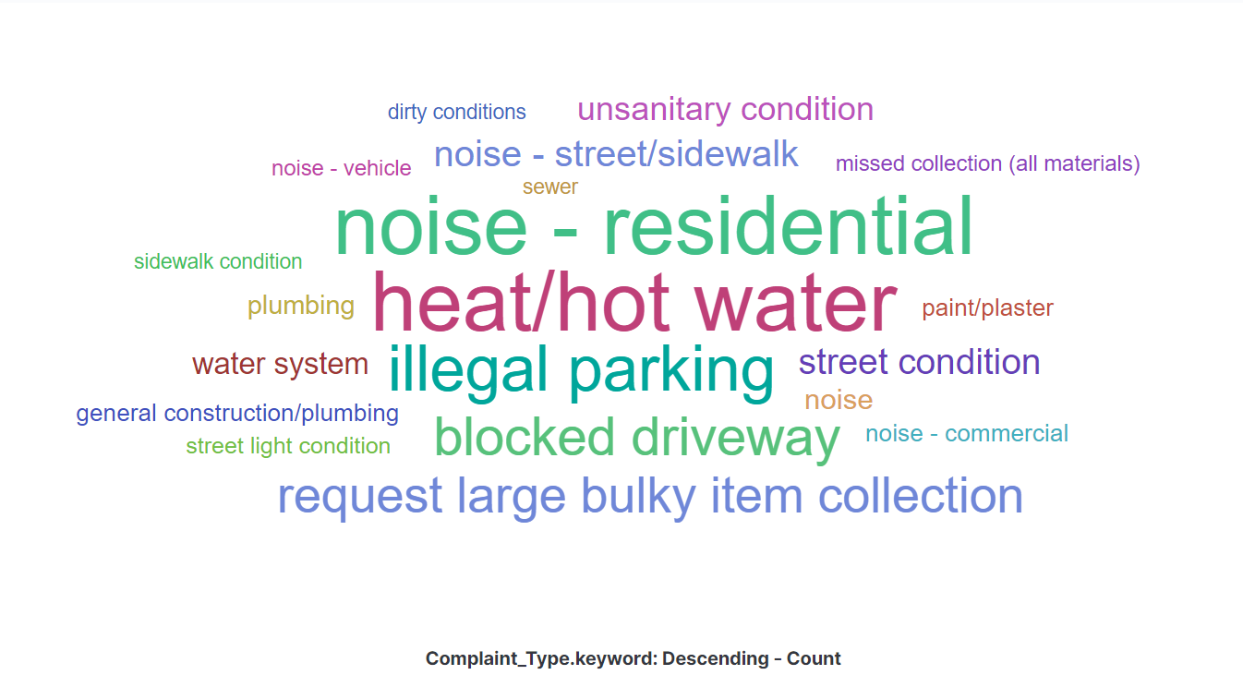

**Figure 4. Top 20 complaints**

Next the top 20 descriptors were examined in a tag cloud. As expected due to the prior visualizations in this report, loud music/party is the largest and most central term in the cloud. The next 2 are “entire building” and “request large bulky item collection.” Previously the term “entire building” did not seem to fit with the other descriptors, however when paired with the amount of complaints about heat and hot water it has more significance. There are many terms in the complaint tag cloud that can account for the large amount of entire building descriptors such as heat/hot water, plumbing, general construction/plumbing, dirty conditions and unsanitary conditions. Similarly, the term loud music/party, noise: construction/after hours, banging/pounding, and loud talking provide more details on the variety of noise complaints the city receives. This explains why “noise - residential” is one of the most common complaints.

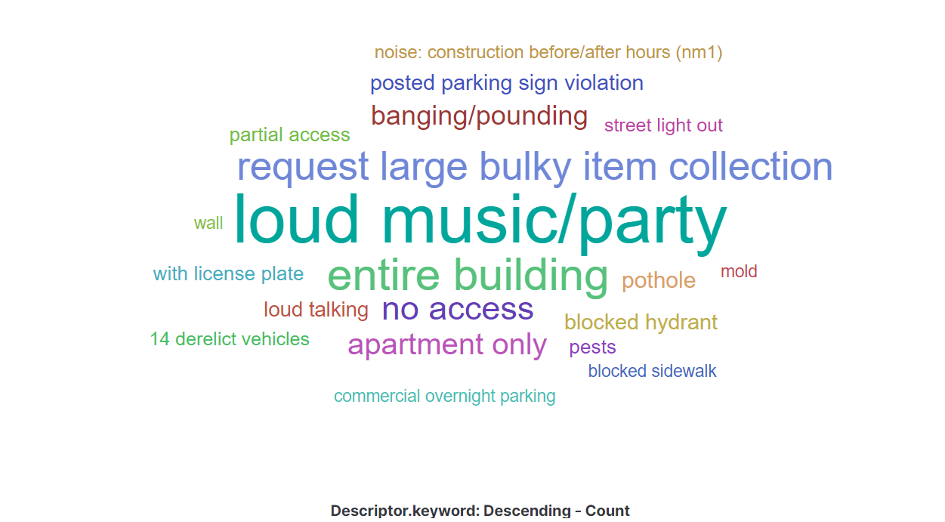

**Figure 5. Top 20 descriptors**

Location of Complaint Calls (Coordinate Maps)

The city of New York has also requested a map of all the major call descriptors in the city. First, a map was created for all of the major call descriptors in the entirety of New York. A map was then created for each of the top 10 cities. All of the maps used a filter for “descriptor” being one of the following: loud music/party, request large bulky item collection, entire building, no access, apartment only, banging/pounding, blocked hydrant, posted parking sign violation, loud talking and partial access. These are the 10 most frequent descriptors. The first map had no filter for “city”, so the results are for all of New York. The following 10 maps filtered for “city”, using the top 10 cities for complaint calls as identified throughout the report. Those 10 cities are Brooklyn, New York, Bronx, Staten Island, Jamaica, Flushing, Astoria, Ridgewood, Ozone Park and Fresh Meadows. Figure 6.1 reveals the majority of service calls occur in the northwest section of New York (New York City and the Bronx) and the just south of the central part of New York (Brooklyn). The fewest calls occur along the eastern part of the city.

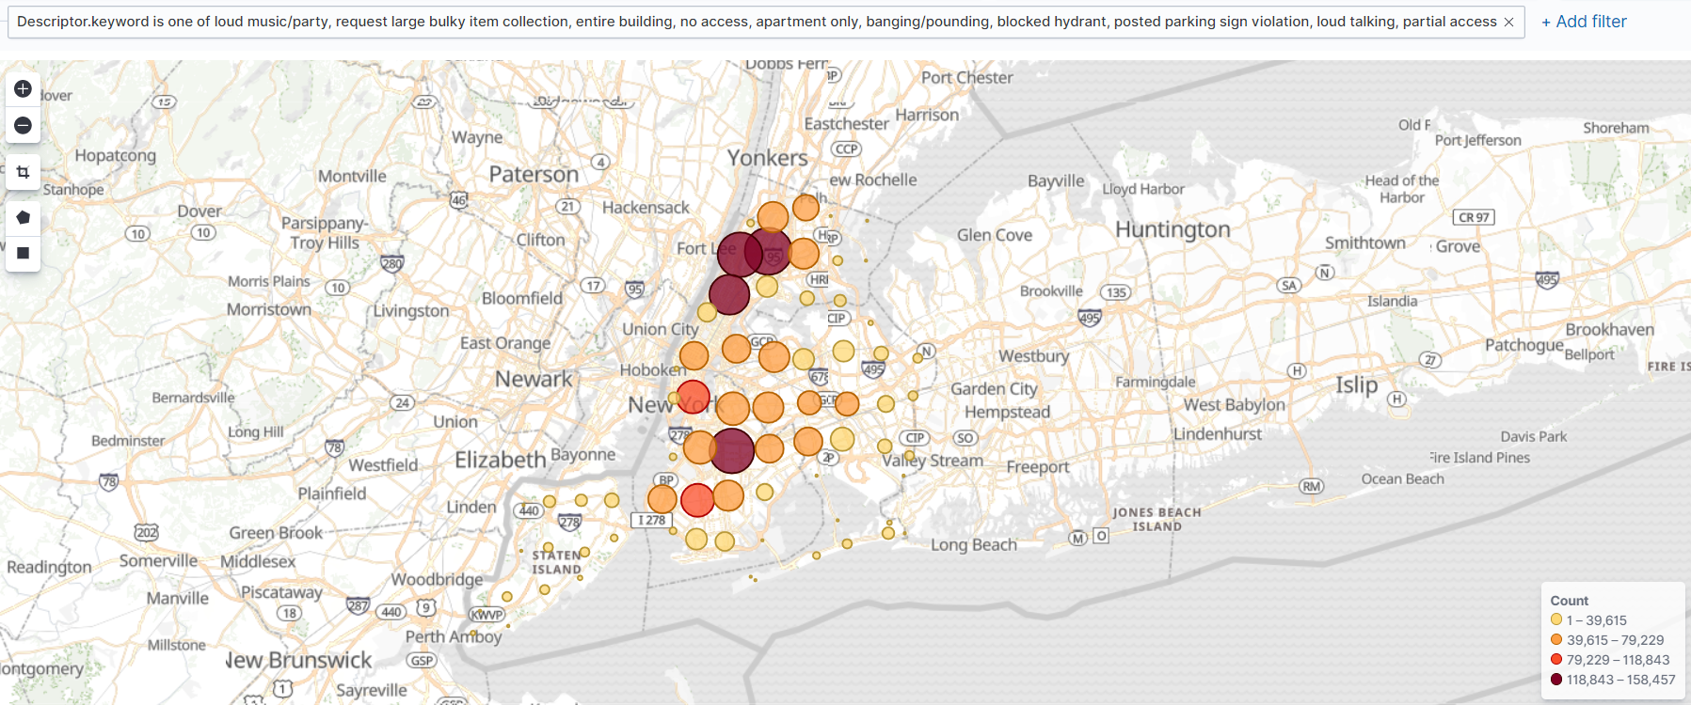

**Figure 6.1. Map of major call descriptors in New York**

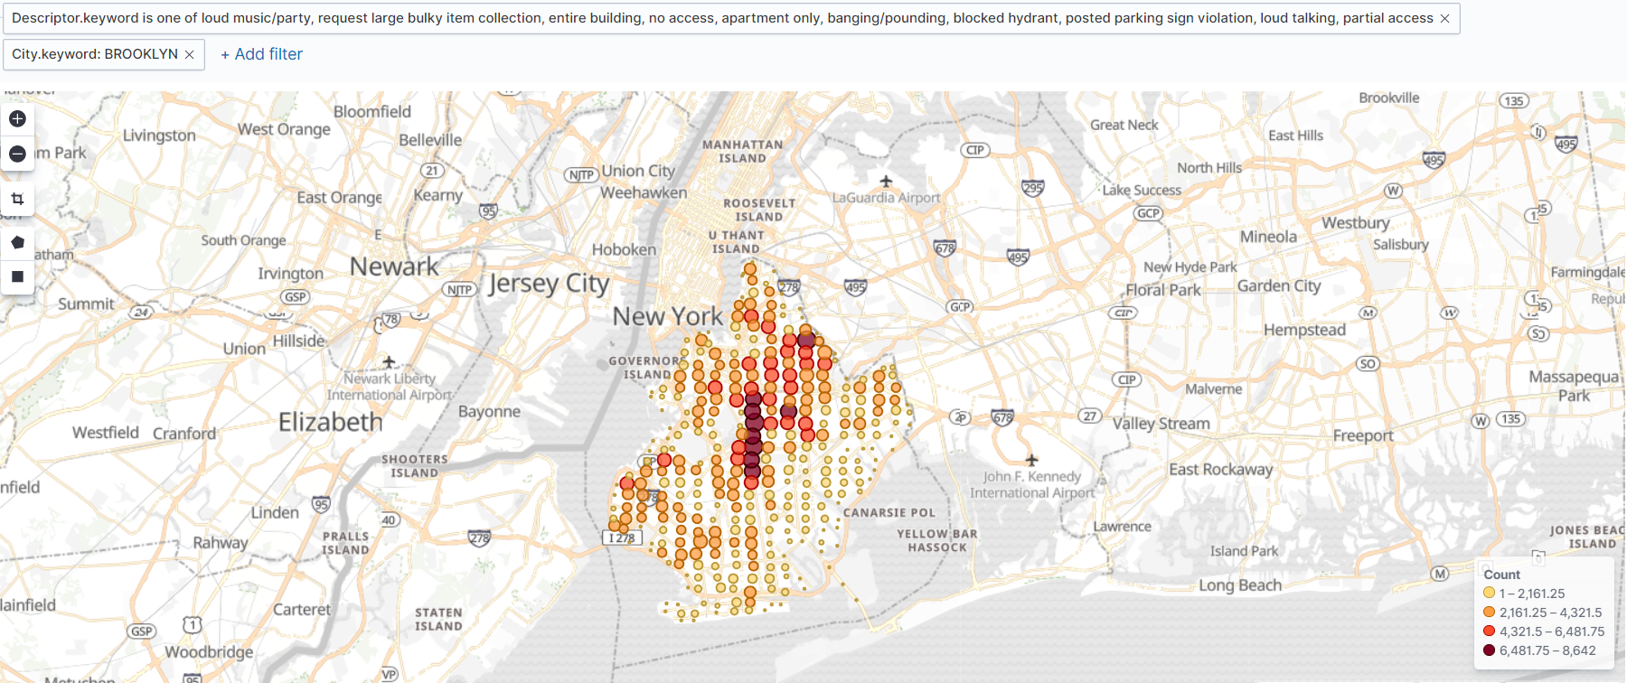

**Figure 6.2. Map of major call descriptors in Brooklyn**

The majority of the calls in Brooklyn (Figure 6.2) occur in the central and northeastern parts of the city. Figure 6.3 reveals that most calls in New York City occur in the northern section, just east of the George Washington Bridge, east of Fort Lee.

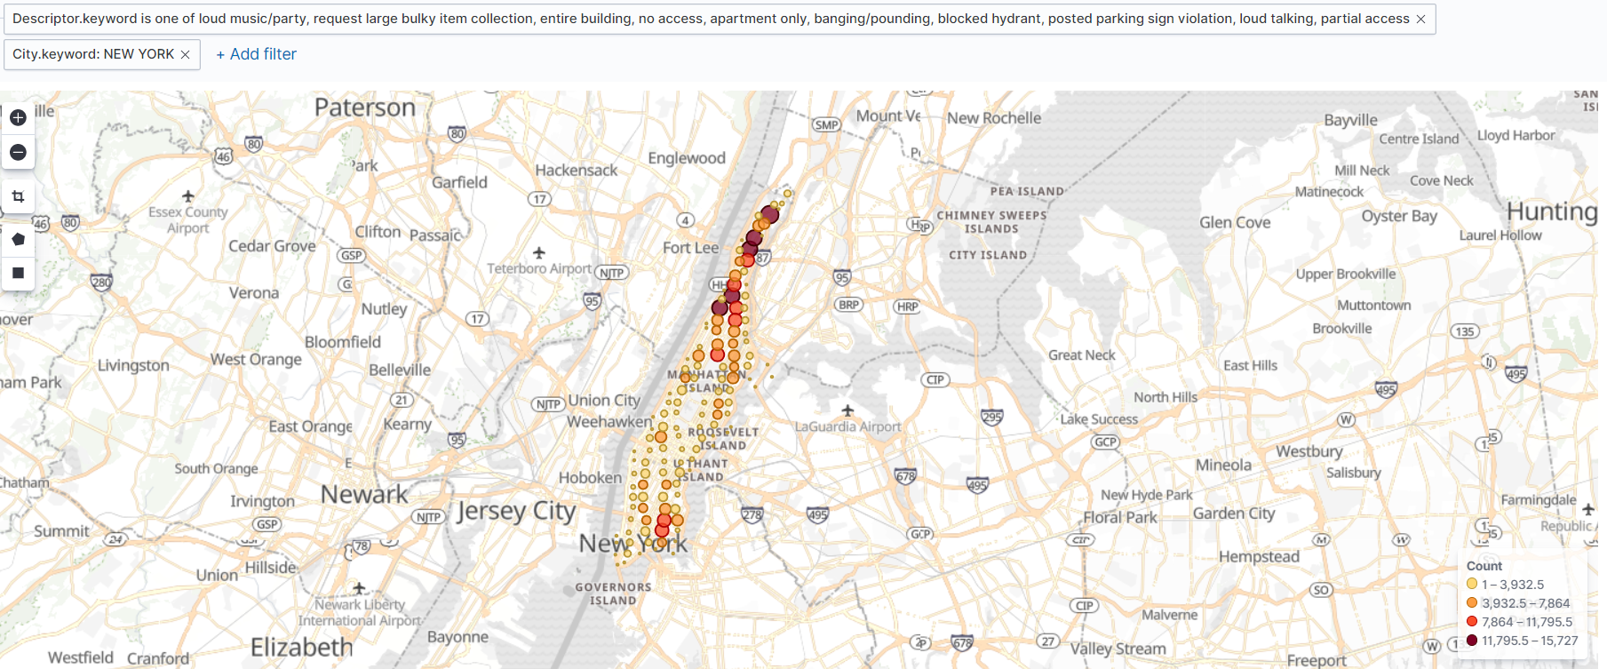

**Figure 6.3. Map of major call descriptors in New York City**

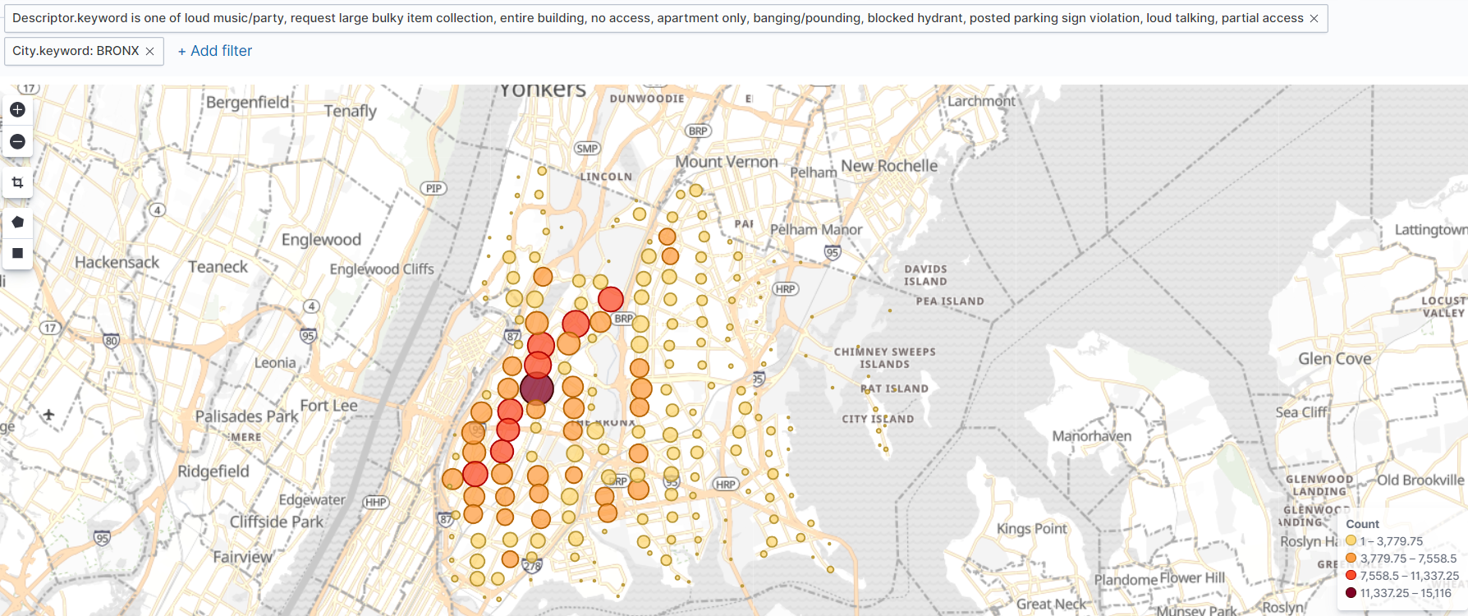

**Figure 6.4. Map of major call descriptors in Bronx**

Service calls in the Bronx (Figure 6.4) occur mainly in the central section, slightly west of centre. Figure 6.5 displays that most service calls occur in the northeastern part of Staten Island. The northwestern section of Jamaica is where the majority of service calls occur in that city (Figure 6.6).

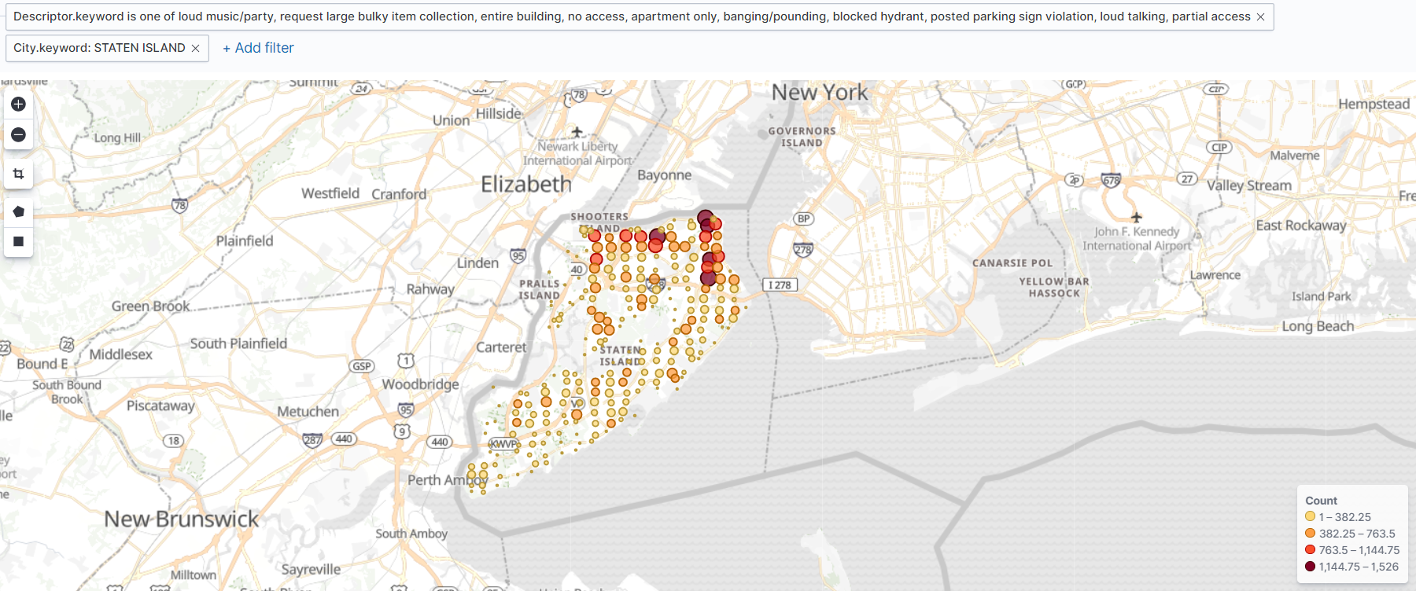

**Figure 6.5. Map of major call descriptors in Staten Island**

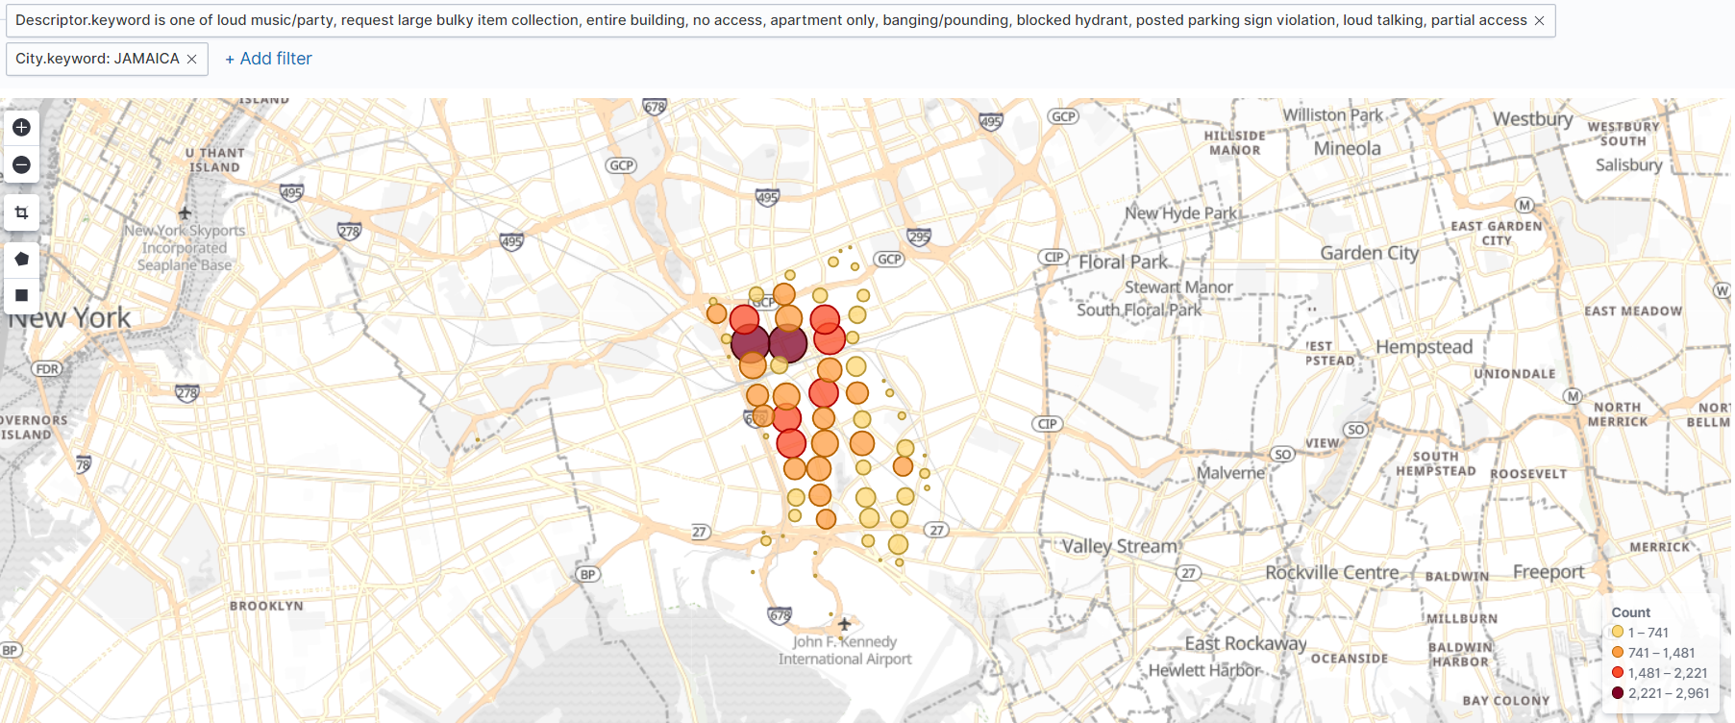

**Figure 6.6. Map of major call descriptors in Jamaica**

In Flushing, service calls are concentrated in the northwestern sector, while central and eastern Astoria are the most common locations for service calls as seen in Figure 6.7 and 6.8.

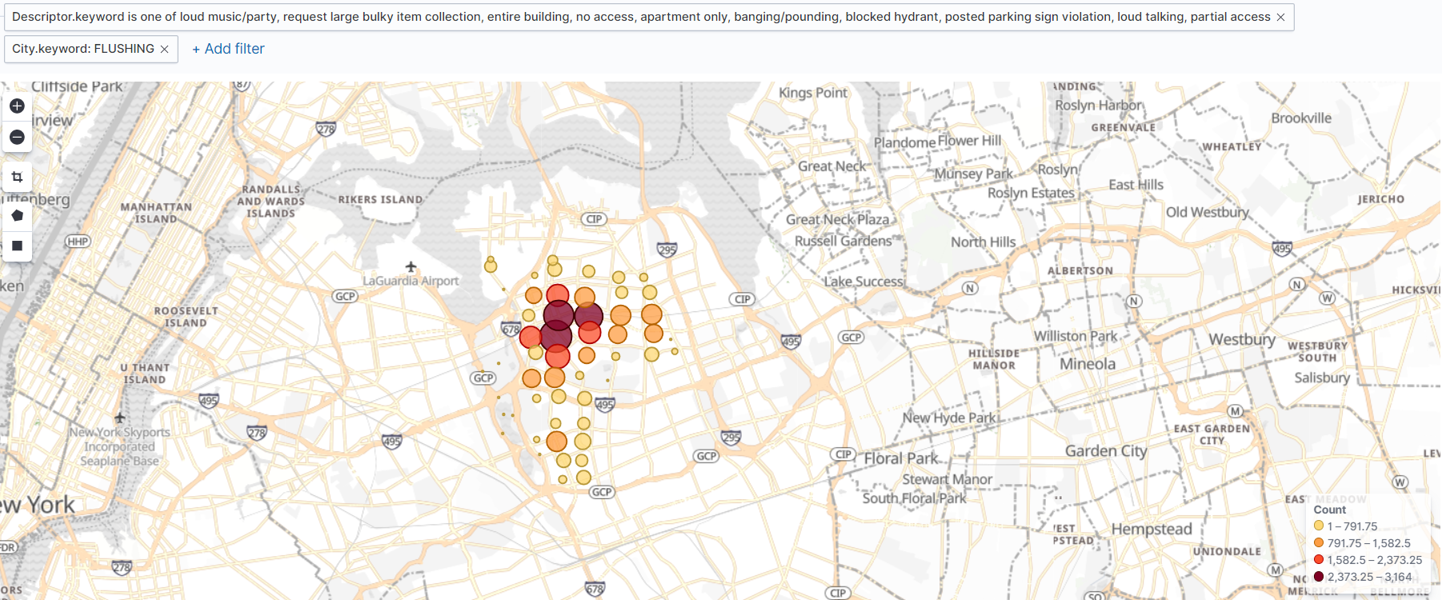

**Figure 6.7. Map of major call descriptors in Flushing**

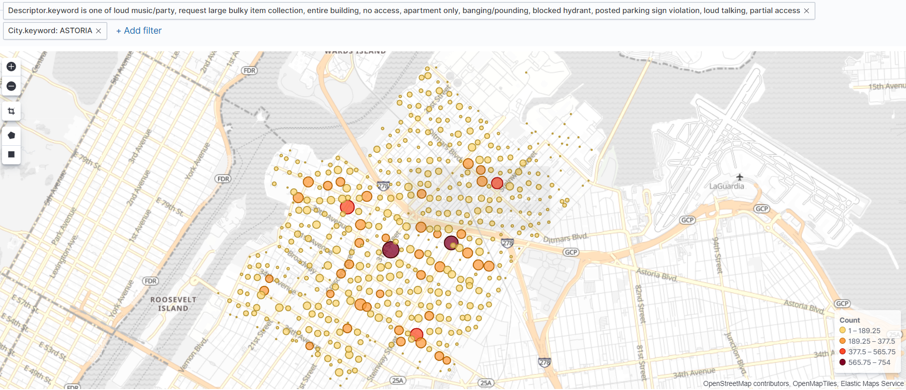

**Figure 6.8. Map of major call descriptors in Astoria**

Figure 6.9 highlights Ridgewood, which has 2 concentrated areas of calls in the west but otherwise the service calls are spread out evenly.

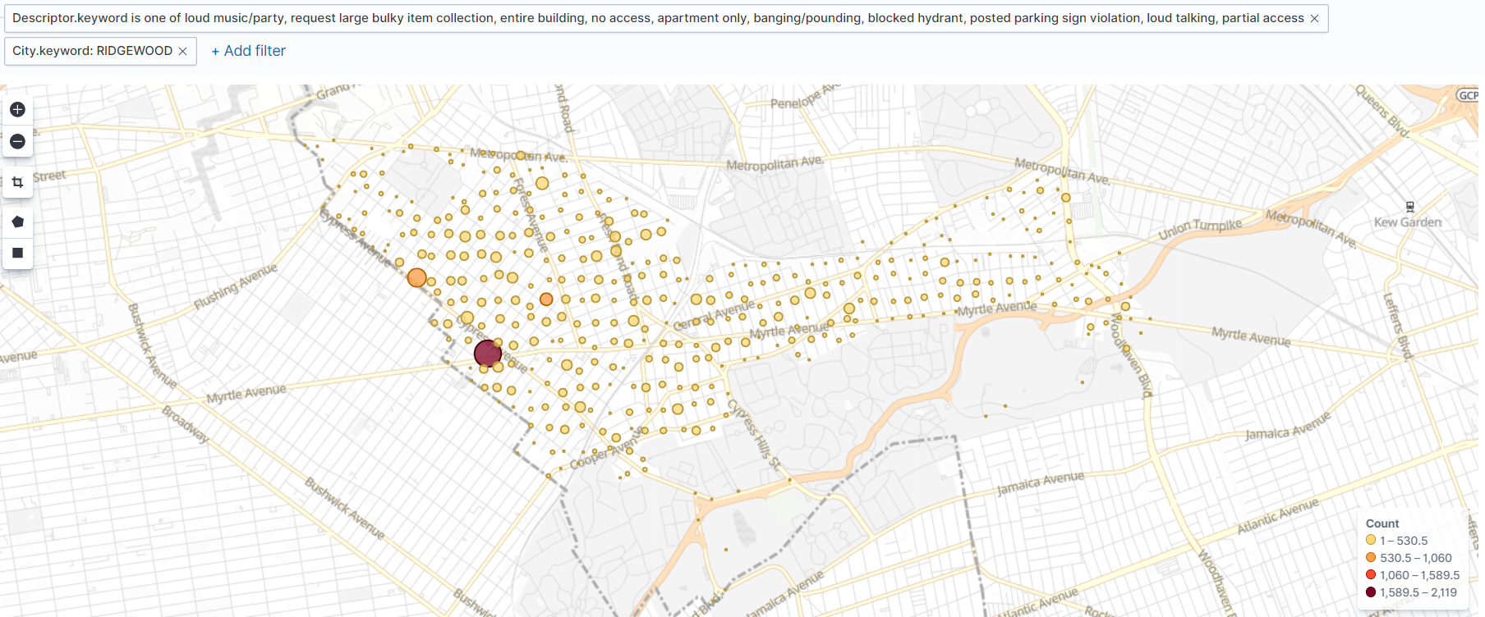

**Figure 6.9. Map of major call descriptors in Ridgewood**

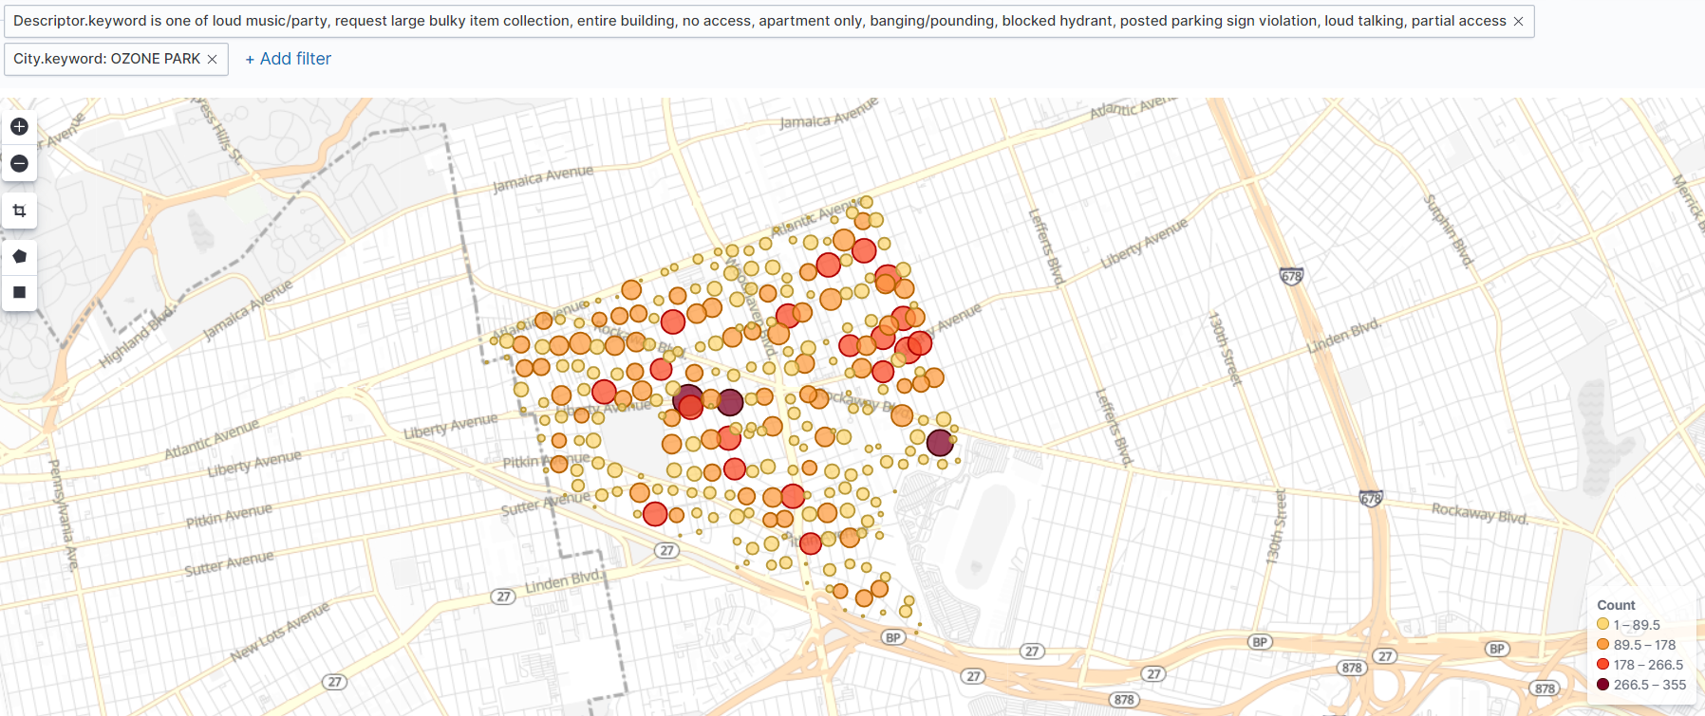

**Figure 6.10. Map of major call descriptors in Ozone Park**

The service calls in Ozone Park tend to occur in the central section as well as the east end, however there are pockets in the southern and northeastern areas with medium to high concentration as well (Figure 6.10).

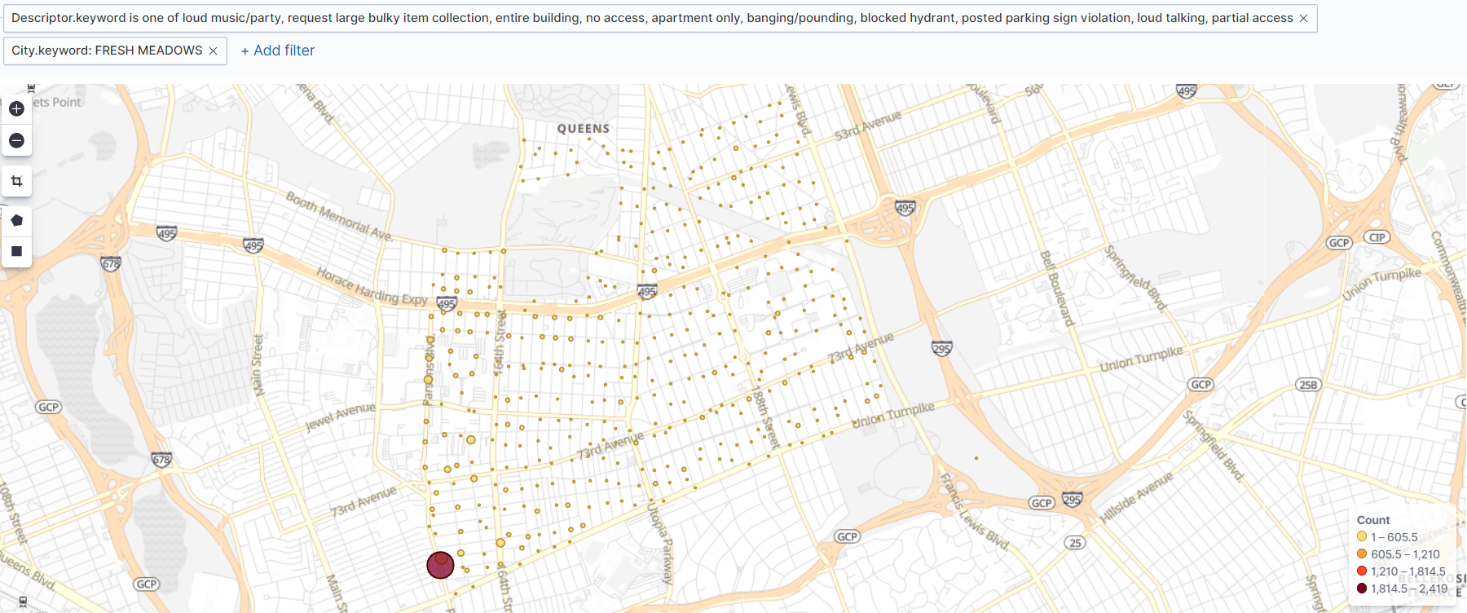

**Figure 6.11. Map of major call descriptors in Fresh Meadows**

Finally, Figure 6.11 examines Fresh Meadows where calls are made throughout the city but the vast majority occur in the southwesten point.

The aforementioned sections highlighted in each map are where the city should focus its resources, especially in Brooklyn, New York City and the Bronx as those areas make up over 3.7 million out of the roughly 5.4 million calls analyzed in this report.

Most Called Agencies and Cities

The top 5 agencies called in New York are the New York Police Department (NYPD, Department of Housing Preservation and Development (HPD), Department of Sanitation of New York (DSNY), the Department of Transportation (DOT), and the Department of Environmental Protection (DEP). The top 5 cities for service calls as previously mentioned in the report are Brooklyn, New York City, Bronx, Staten Island and Jamaica. Figure 7 reveals that the NYPD gets calls from Brooklyn far more than any other city. The HPD has most of its calls made to the Bronx, the only department that does not receive the majority of its calls from Brooklyn. The second most calls the DSNY receives come from Staten Island, however Brooklyn is still far and away the most common city. Jamaica ranks 5th in terms of calls made to each department. Knowing this information is critical to knowing where to assign the government resources in order to keep New York running as efficiently and safe as possible.

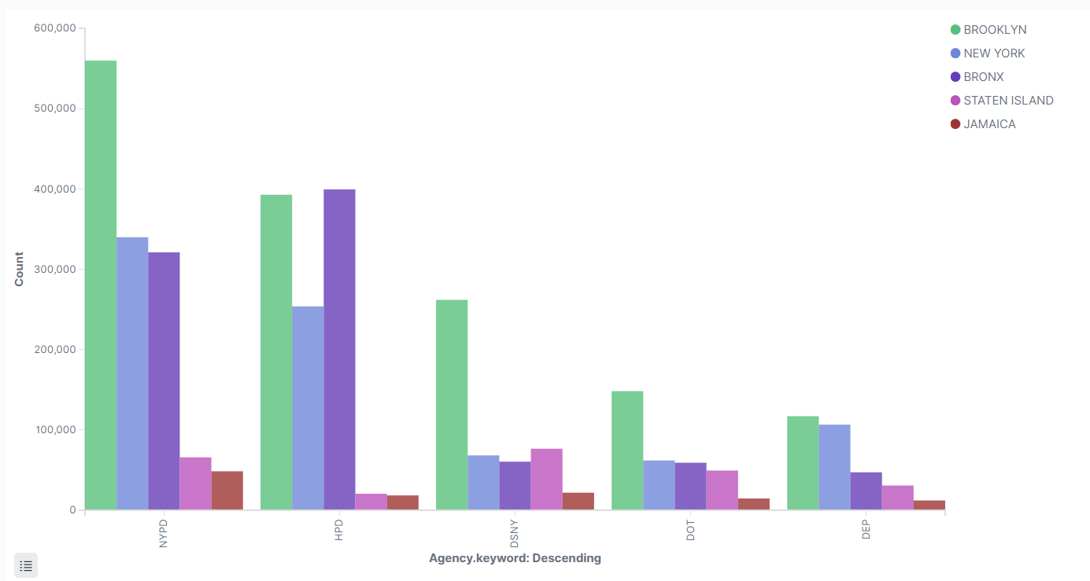

**Figure 7. The top 5 agencies called and the top 5 cities by complaint calls**

Ease of access, Kibana Dashboard

Finally, the charts and graphs can be accessed easily in the Kibana dashboard. If required visualizations can be added, edited or removed. Figure 8 contains all of the previous figures found throughout the report. As new data is received, the graphs can be modified to reflect the changes while still keeping them in the same location.

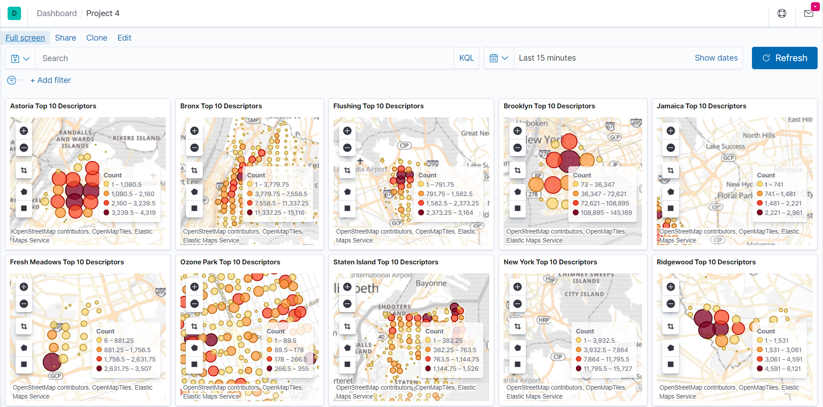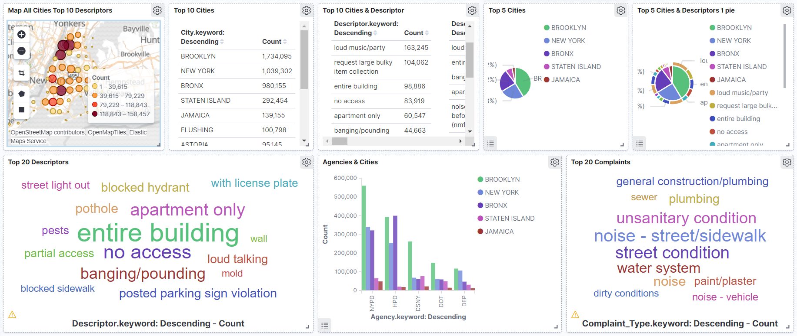

**Figure 8. Kibana Dashboard with all visualizations**

# Appendix

## Logstash File

Below is the logstash file used to load all of the data into the Elasticsearch index titled “servicecalls”. All columns are listed in the filter section. Agency and City were mutated to uppercase while Complaint Type, Address Type, Vehicle Type and Descriptor were mutated to lowercase. The latitude and longitude fields were converted to float, and a new field was created titled “geoLocation”, which contains “%{Latitude}, %{Longitude}” to allow these numbers to be read as coordinates. This enables the creation of coordinate maps.

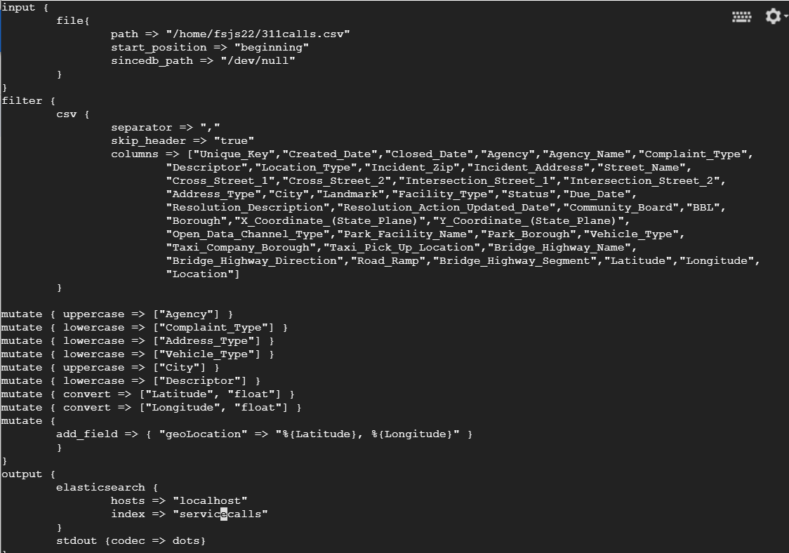

**Image 1. Logstash file**

## Geo-Point Template

Below is the template created which allowed the Geo-Point functions of Kibana to be used. The template was titled “project4”, applied to the “servicecalls” index pattern. In the “properties” section of the mapping, the field “geoLocation” (created in the logfile) was converted to the type “geo_point”. This means that this field will be read as coordinates. The application of the new template was confirmed with a message (“acknowledged” : true). If desired, other conversions could have been made in this field with regards to text type and dates, but for the purposes of this report only the geo_point conversion was applied in this section.

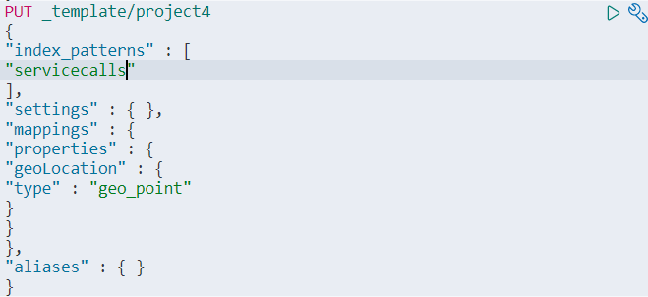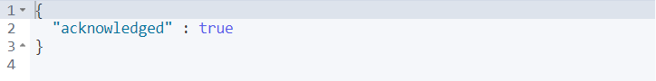

**Image 2. Geo-Point Template**